**Transcript Record**

**Personal Information:**

Name: Praveen N Swamy

Reg. no: 21BCG10009

Branch: Computer Science and Engineering with Specialization in Gaming Technology

School: SCSE (School of Computer Science and Engineering)

**Attended Courses:**

1. Introduction to Computational chemistry
2. Environmental Sustainability
3. Introduction to Problem Solving and Programming
4. Electric Circuits and Systems
5. EFFECTIVE TECHNICAL COMMUNICATION
6. Calculus and Laplace Transforms
7. Fundamentals in AI & ML
8. Object Oriented Programming With C++
9. Database Management Systems
10. Advanced Technical Communication
11. Discrete Mathematics And Graph Theory
12. Programming in Java
13. Design Analysis Of Algorithm
14. Game Programming using Unity
15. Differential And Difference Equations
16. Engineering Design and Modelling
17. Data Structures and Algorithm
18. Computer Vision and Robtics……. etc.

**Total Credits Earned:** 114 (The Highest grade is **S** and the lowest one is **E**)

S- 3

1. 18
2. 9
3. 3

**GPA:** 9.0

**Duration of Course:** Sixth semester (Ongoing)

**Screenshot of Marks cum grades of previous Sem:**

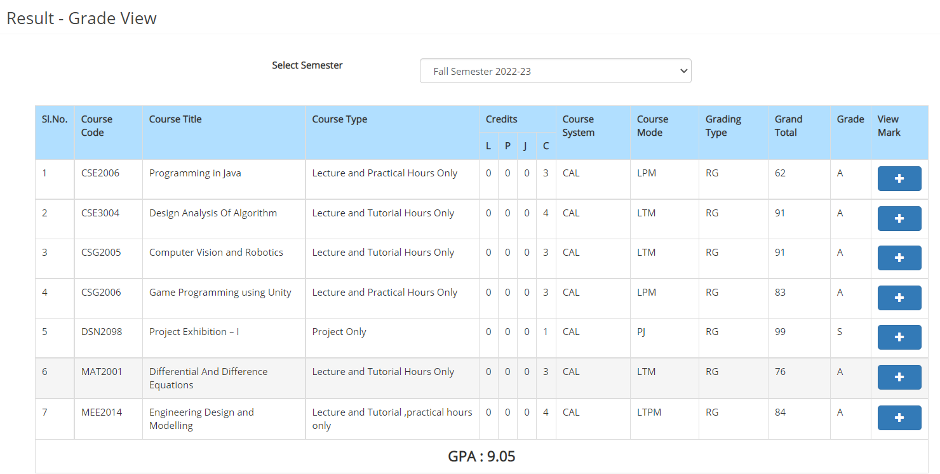

**Achievements:**

* Participated in Bajaj HackRx 4.0 and got awarded as the best concept and best project award and came as the winner.
* Contributed in the Winter open source code challenge and secured an All India Ranking of 200 among nationwide competition.
* Stood in Top 2 in Code-VIT competition.
* Research in Rocket Motor Exhaust for powerful thrust and uplift.